**An Investigation Mining Community Locations with**

**Respect to Average Household Income**

**Munir Yousef**

**December, 2018**

**Introduction**

There are mining towns scattered across the United States. In most cases, mining camps came first, and communities built up around them. These communities have a number of different aspects that can be analyzed along demographic lines to better understand how earning potential in households are impacted by the presence of mining operations. This too can take many forms including educational achievement, etc. While all of these are important to analyze together, this study focused average household income in mining communities by County.

**Research Questions.**

To better understand the communities that mining camps are situated in, demographic data on the attainment of average income by county was analyzed. Since this may be both a national and localized phenomenon, the analysis included both a national perspective and a local one. Westchester County in New York State was used for local analysis. The study attempted to Analyze:

1. What is the distribution of average income in mining towns in the continental United States and locally in Westchester County.
2. What is the distribution of counties with average income (both locally and nationally)
3. What mining towns are in the designated demographic (Average income with Bachelor’s degrees attained less than the Mean).

**Methodology**

The development environment for this study was ESRI ArcGIS Arcmap.

This study used data from Social Explorer’s Education data set. Social Explorer has a wide variety of demographic data sets including:

1. Education
2. Employment
3. Family
4. Housing
5. Income
6. Poverty
7. Real Estate

To get a base map of counties, the study used US Census Bureau Tigerline 2018 data. Social Explorer Education Attainment data was joined with County data to perform geographic analysis.

To select counties with a specific demographic character (e.g. Average Income < mean), the joined layer was used. Finally, to specifically select those mining communities within the selected demographic layer selection by location was used.

**Results**

In the discussion below, both the Continental US and Westchester County were analyzed (and shown). Local analysis may require more investigation since the number of mining communities were limited.

The base maps and initial demographic showed dense concentrations of mining towns in urban centers in the east coast. The mining towns are sparse on the western half of the country.

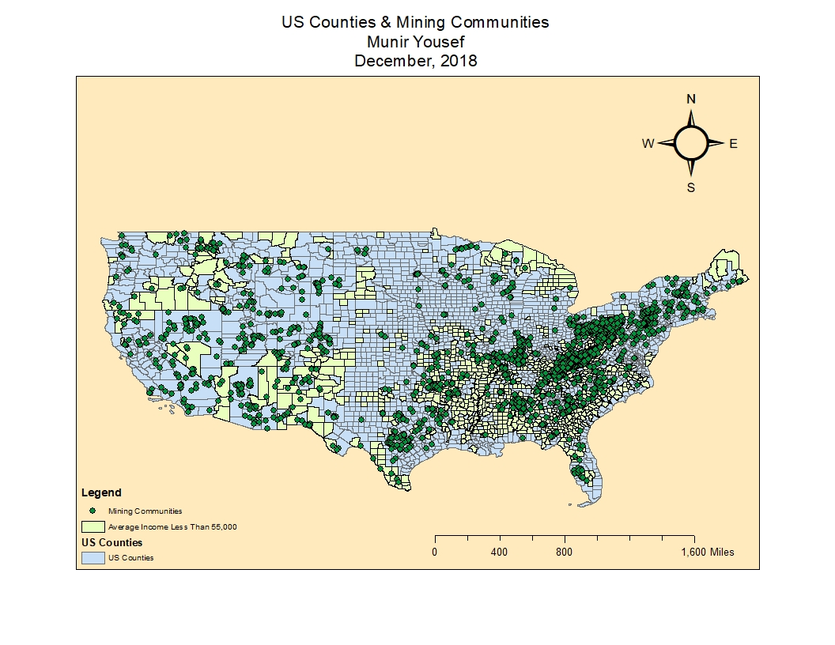

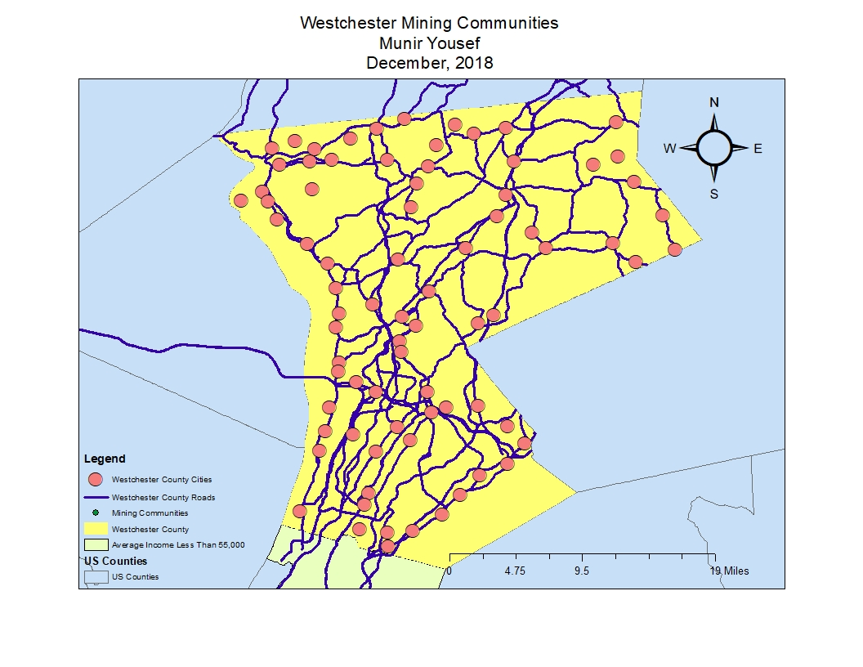

Showing the demographic distribution (color-coded map), when looking at where mining communities are situated, visual analysis indicated higher concentrations/density in those counties with low bachelor’s degrees. Further research as to why this might be the case is warranted. 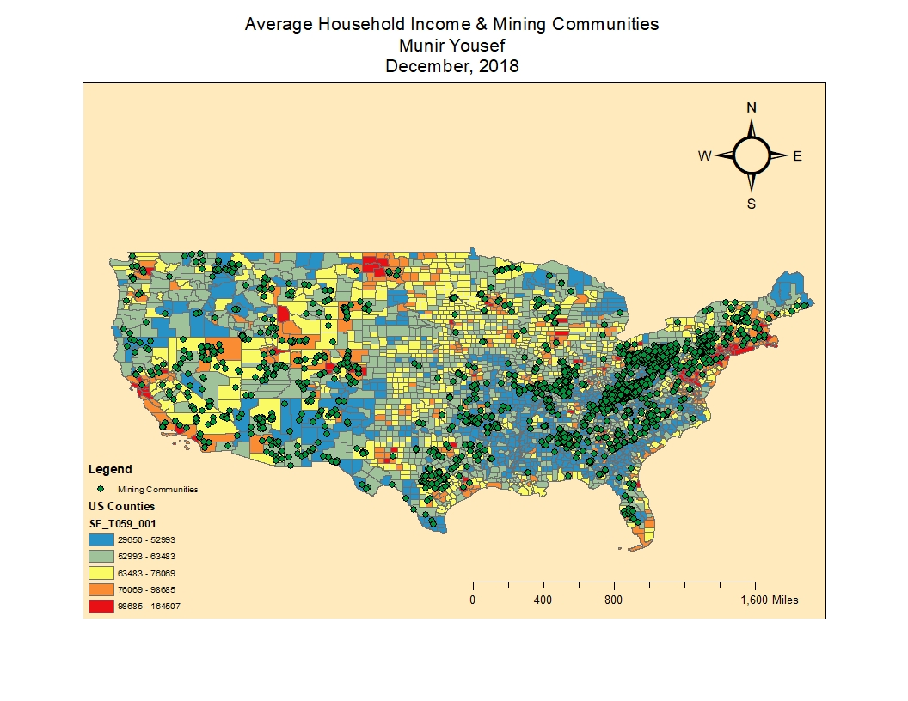

*Although mining communities have a higher concentration on the eastern half of the country, the highest density of mining communities appear to also be the communities with the lowest average household income. The lowest average household income is the most dense in the mid to mid-eastern part of the country.*

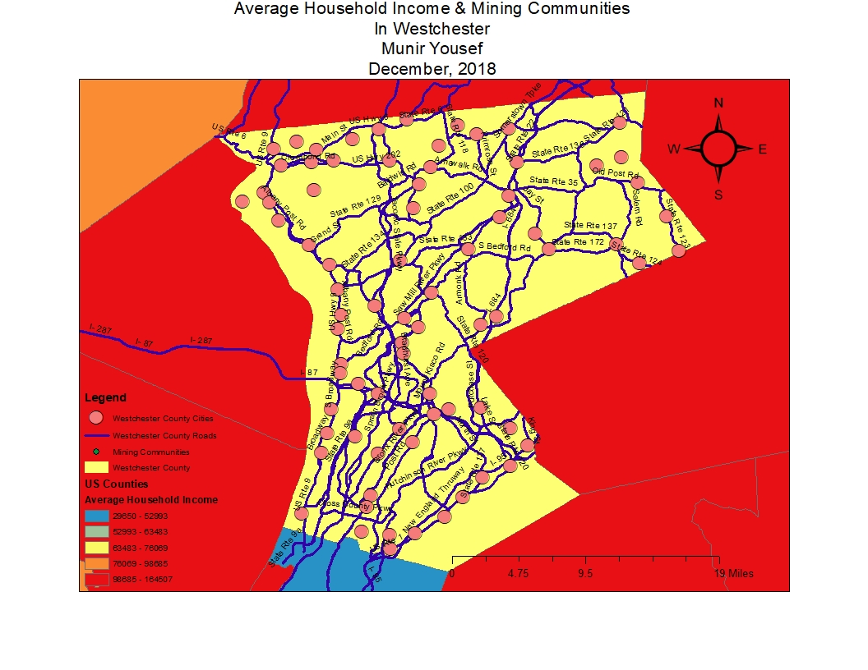

*The zoomed map of Westchester county with average income shows that Westchester county does not have any mining communities and enjoys a higher than average household income. The neighboring counties also have a higher than average household income which appears to fit the national trend.*

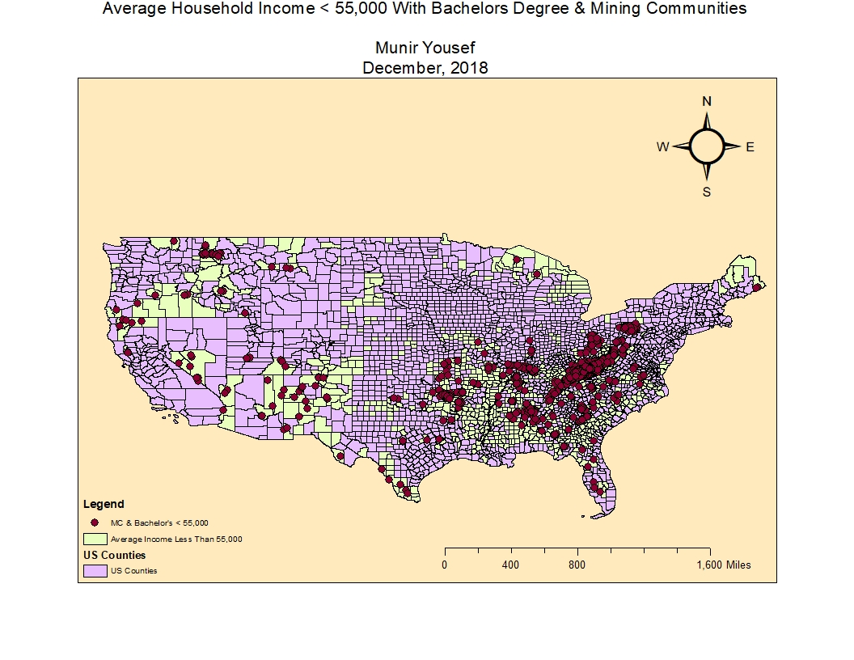

*The above selection illustrates the correlation between the average income of households less than 55,000 and the bachelor’s degree holders in mining communities. The results indicate that mining communities on average receive less than 55,000 dollars per year unless a bachelor’s degree has been attained. The results also show that the majority of bachelor’s degree holders live on the east coast.*

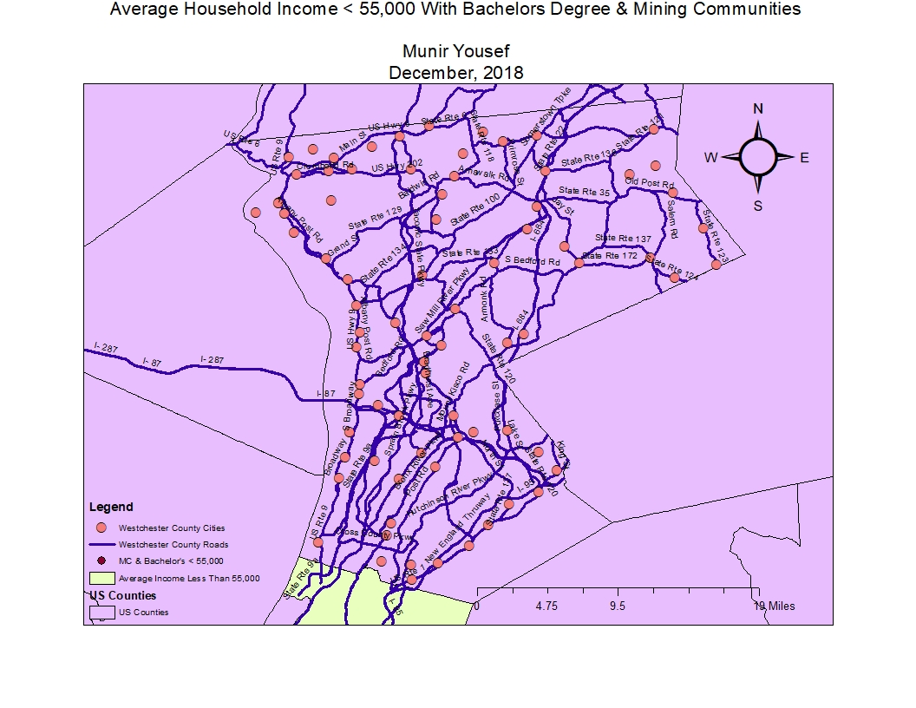

*The zoomed map indicates that there are no mining communities in Westchester county. The map also indicates that Westchester County also has an average household income that is more than 55,000.*

**References** (you must put your description in 3 and 6 below).

1. ESRI, ArcMap 10.6.1, ESRI, Inc., URL: http//www.esri.com
2. US Census Bureaa Tigerline Counties, URL: <https://www.census.gov/geo/maps-data/data/tiger-line.html>, 2018
3. Mining : URL: https://www.socialexplorer.com/tables/ACS2016_5yr/R11960323
4. US Cities, National Map, URL: <https://nationalmap.gov/small_scale/atlasftp.html?openChapters=chpref#chpref>
5. US Census Bureu New York State Primary and Secondary Roads, URL: <https://www.census.gov/geo/maps-data/data/tiger-line.html>, 2018

6. Mine and mineral resources URL: <https://hifld-> geoplatform.opendata.arcgis.com/datasets/mines-and-mineral-resources